- Open System Preferences
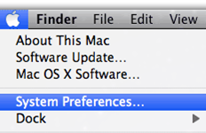

- Click on Printers & Scanners
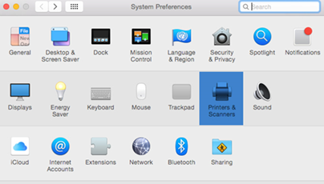

- Click on the + sign to add a printer, fax, or scanner
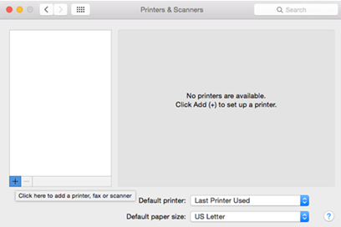

- In the search field, type in the name of the printer you are looking for
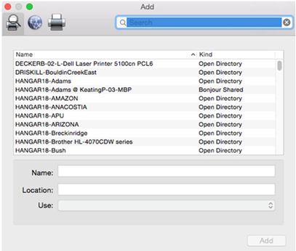
- Select the printer by single-clicking it from the list
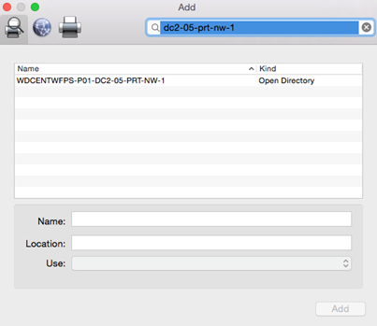

- Click Choose Driver and select the Generic PLC Printer option, then click Add to complete the installation


