Using the Windows 10 Search function, search for Run and click when populated. Or users Windows Key + R to launch the Run Box.
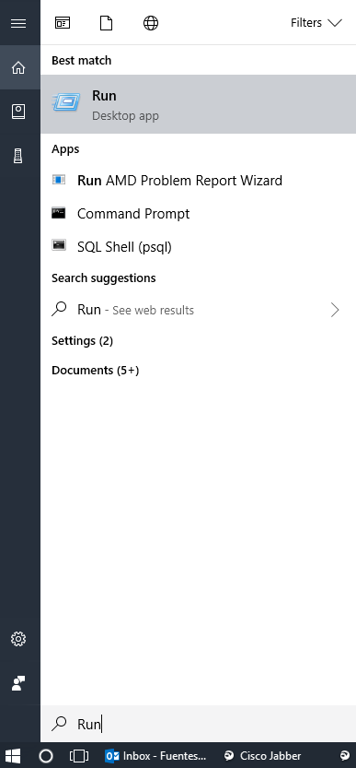
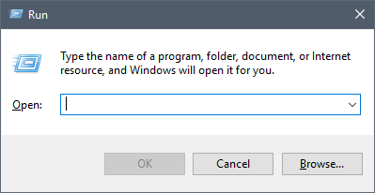

Type \\printserver where you replace “printserver” with the name of your local print server.
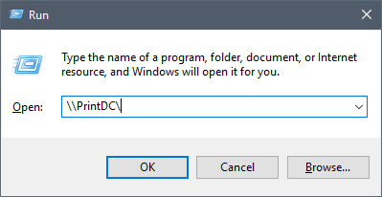
- DC Office users: Type \\printwdc.myeab.com
- Bloomington office users: Type \\printmin
- London office users: Type \\printlon
- Plymouth Meeting office users: Type \\wfpsp01
- Richmond office users (Parham Place): Type \\printric.myeab.com
- Richmond office users (Northrun): Type \\printnr.myeab.com

Double-click on the printer you would like like to add to your computer and the Windows Printer Installation dialogue box will pop up.

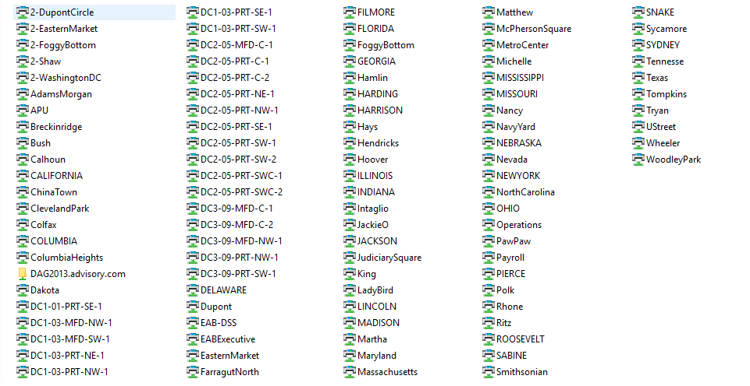

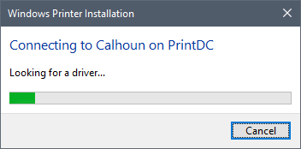
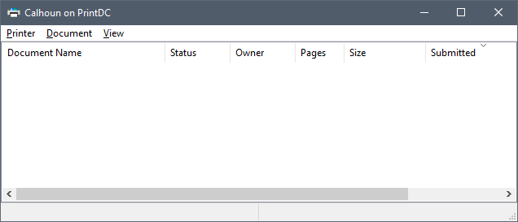
You can verify if the printer was successfully installed by going to Start > Settings > Devices> Printers and Scanners.
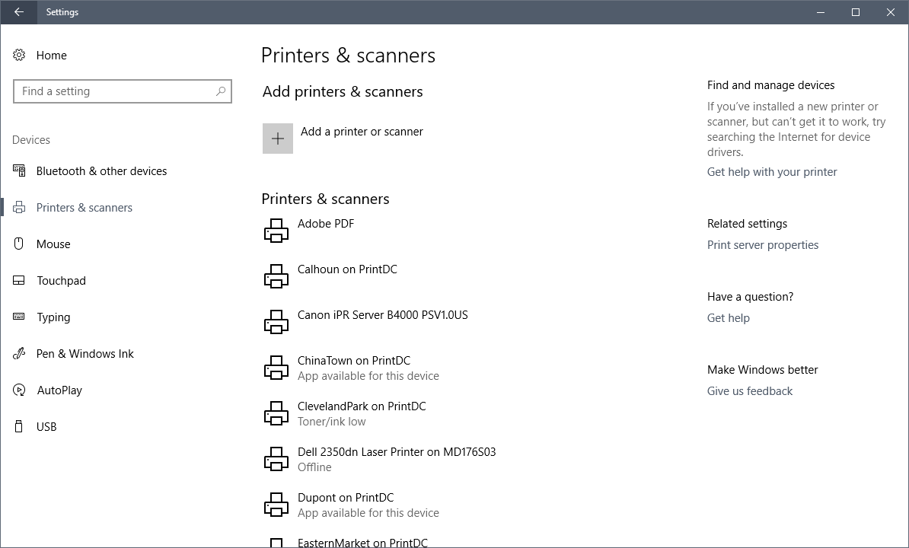
Need Help? Contact the EAB Service desk at servicedesk.eab.com

